DesignTorontoWeb

Att. David Schryver

400 Applewood Crescent u100

Vaughan, ON

L4K 0C3

Johannes Weber

3048 Venables St

V5K 2S1

Vancouver, BC

[johannes@drweber.de](mailto:johannes@drweber.de)

+1 604 308-8308

Vancouver, June 25, 2022

Dear David,

I would love to help increase the number (18,000?) of cups of coffee consumed at DesignTorontoWeb! ☺

My name is Johannes Weber and I'm a recent LighthouseLabs grad seeking to transition from Live and Broadcast Production to a web development career. I have been passionate about coding for many years and have regularly written Node/Express apps – sometimes interfacing with hardware through RaspberryPI or ESP32 micro-controllers - to solve problems, automate processes or otherwise streamline tasks in my role as the head of the production department at Tenth Church. Among other things the LighthouseLabs bootcamp experience allowed me to learn modern JS, git, React, and working remotely in teams.

I found your job posting on LinkedIn and I would be grateful if you considered my application.

If you have any questions, please do not hesitate to contact me. I’m looking forward to connecting with you.

Thank you for your time,

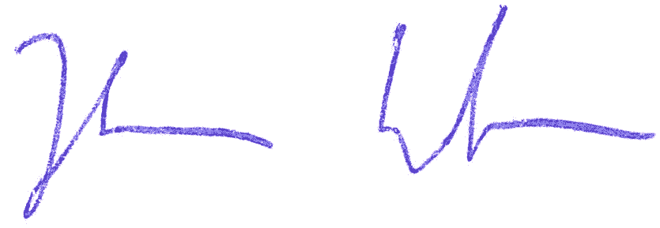

Johannes Weber